NCTE REPORT
(Session 2020-2021)

- Sanctioned Programs along with annual intake in the institute for the session 2020-2021
Sr. No. | Course | Seats
 |  | Total | Filled
1. | M.ed | 50 | 19
2. | B.ed | 100 | 78

- Name of the faculty and staff in full as mentioned in school certificate along with their qualifications, scale of pay and photograph
Sr. No. | Faculty Name | Designation | Nature of Appointment | Qualification | Scale | Photograph
1. | Dr. Jagdeep Kaur | Principal | Permanent | M.SC.( Botany), M.Ed  UGC-NET ( Education)  Ph. D Education | 37,400-67000+ 10000(AGP) | 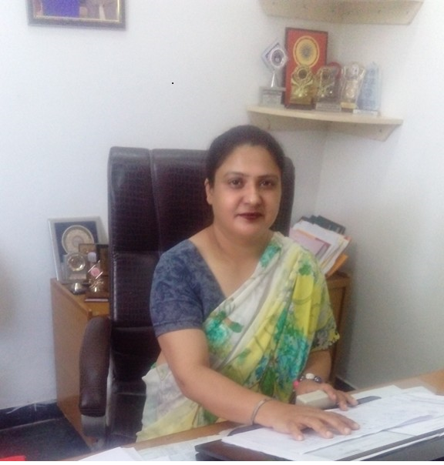
2. | Dr. Rajinder Kaur Gill | Associate Professor | Permanent | M. A. (Economics)  ( Sociology)  M.Ed  UGC-NET  ( Education)  Ph. D Education | 37,400-67000+ 9000(AGP) | 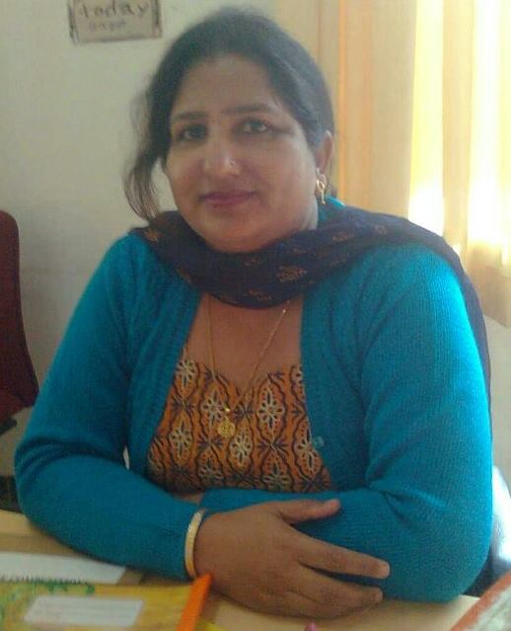
3. | Dr. Loveleen Chauhan | Assistant Professor | Permanent | M.Sc( Food and Nutrition)  M.Ed  M.Phil  UGC-NET  ( Education)  Ph. D Education | 15,600-39,100+ 6000(AGP) | 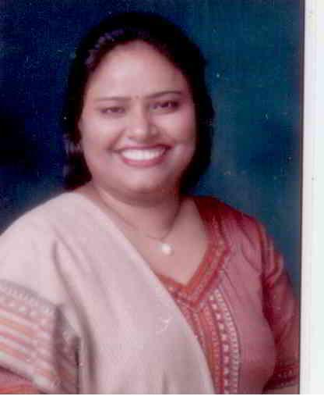
4. | Dr. Anjali Sharma | Assistant Professor | Permanent | M.A( History)  M.A. (Pol. Sci.)  M.Ed  UGC-NET  ( Education)  Ph. D Education | 15,600-39,100+ 6000(AGP) | 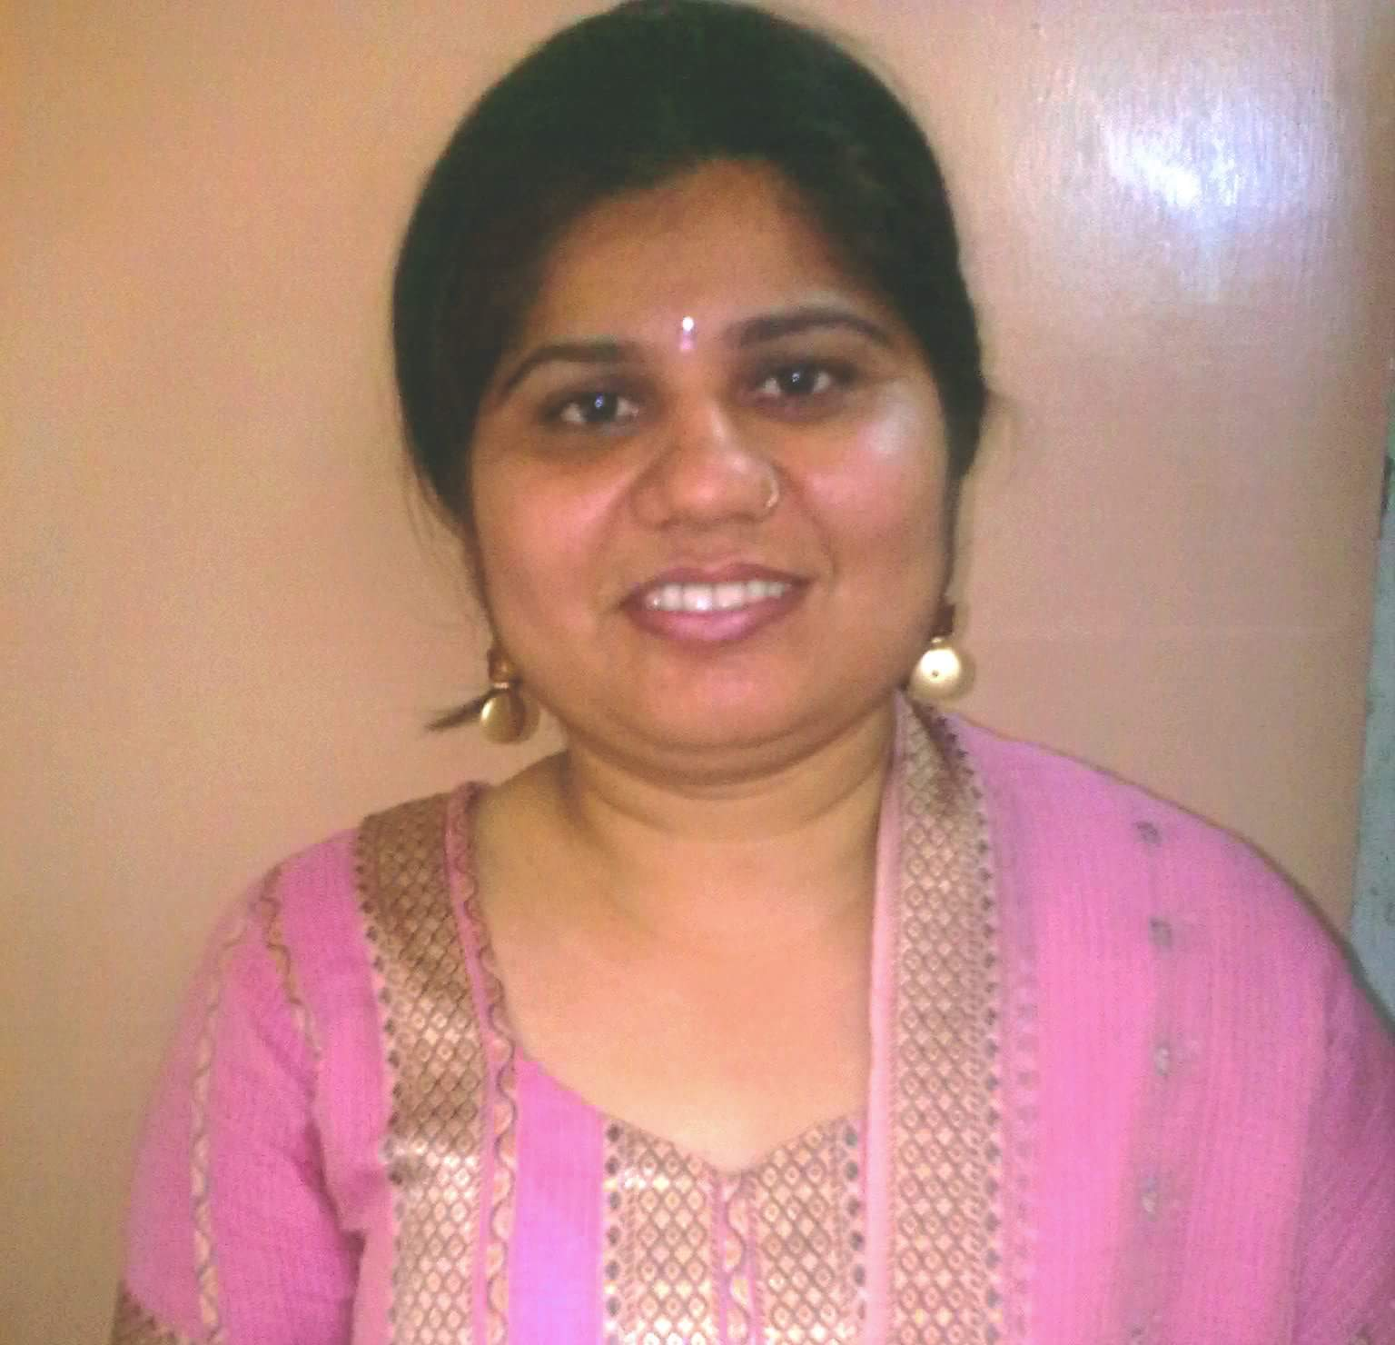
5. | Mr. Sunil Kumar | Assistant Professor | Permanent | M.A. ( Hindi))  M.Ed  UGC-NET  ( Education) | 15,600-39,100+ 6000(AGP) | 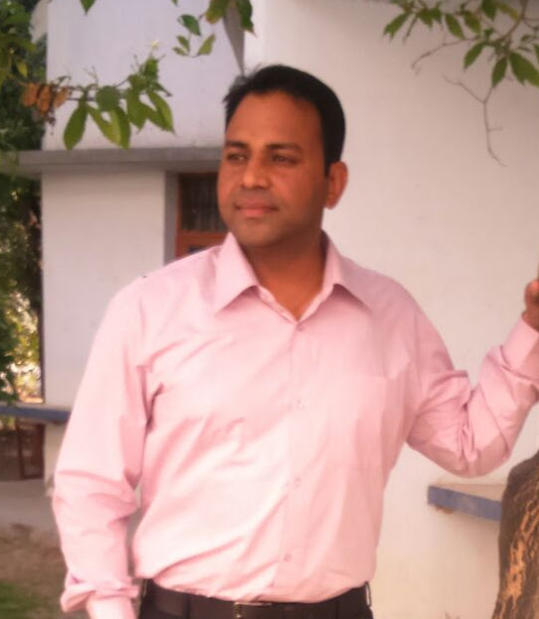
6. | Mr. Madhu Sudan | Assistant Professor | Permanent | M.A. (Economics)  M.Ed  UGC-NET  ( Education) | 15,600-39,100+ 6000(AGP) | 
7. | Dr. Pallavi Pandit | Assistant Professor | Permanent on Probation | M.A. (Sociology)  M.Ed  UGC-NET  ( Education)  Ph. D Education | 15,600-39,100+ 6000(AGP) | 
8. | Dr. Prabhjot Kaur | Assistant Professor | Permanent | M.A. (English)  M.Ed  UGC-NET  ( Education) | 15,600-39,100+ 6000(AGP) | 
9. | Ms. Shweta Passi | Assistant Professor | Adhoc | M.A. (English)  M.Ed | 8000-275-13,500 | 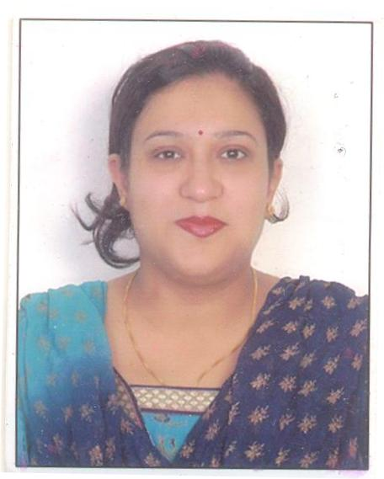
10. | Mr. Nitin Kumar Sahota | Assistant Professor | Adhoc | M.A. (Music)  M.Ed | 15,600-39,100+ 6000(AGP) | 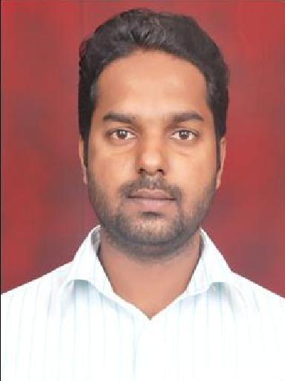
11. | Ms. Sushma Kumari | Assistant Professor | Adhoc | M.A. (Hindi)  M.Ed | 15,600-39,100+ 6000(AGP) | 
12. | Mr. Aprinder Pal Singh | Assistant Professor | Adhoc | M.A. (Punjabi)  M.Ed | 8000-275-13,500 | 
13. | Mr. Gurinder Singh | Assistant Professor | Adhoc | M.Sc.( Mathematics)  M.A.( Economics)  M.A.( Punjabi)  M.Ed | 19,096/- | 
14. | Ms. Seema Thakur | Librarian | Permanent | M.Sc.( Biotechnology)  M.Lib. Science  UGC- NET  ( Lib. Sci) | 15,600-39,100+ 6000(AGP) | 
15. | Mr. Pawanjeet Singh | Sports Officer | Adhoc | B.P.Ed. | 15,000/- | 

- No one left the college during the last quarter
- Name of the students admitted during the current session
Serial No. | College Roll No. | Student Name
1 | 2001 | ANMOL
2 | 2002 | NEHA SHARMA
3 | 2003 | EKTA DEVI
4 | 2004 | JASPREET KAUR
5 | 2005 | ESSHA
6 | 2006 | MAMTA DEVI
7 | 2007 | MAMTA KUMARI
8 | 2008 | PARAMPREET SINGH
9 | 2009 | MANPREET KAUR
10 | 2010 | SAVERA KUMAR
11 | 2011 | AAYUSHI BARDA
12 | 2012 | PRABHJIT KAUR
13 | 2013 | KAMALPREET KAUR
14 | 2014 | DIKSHA
15 | 2015 | SIMRAN SHARMA
16 | 2016 | MANPREET KAUR
17 | 2017 | ANJALI
18 | 2018 | KANWALPREET KAUR
19 | 2019 | SIMRANJEET KAUR
20 | 2020 | ADITI
21 | 2021 | MANPREET
22 | 2022 | DHARMPREET KAUR
23 | 2023 | MANPREET KAUR
24 | 2024 | JASPREET KAUR
25 | 2025 | GURPREET KAUR
26 | 2026 | NEHA
27 | 2027 | MANDEEP KAUR
28 | 2028 | PARVEEN KAUR
29 | 2029 | SAMANDEEP
30 | 2030 | GURPREET KAUR
31 | 2031 | DIMPY SINGH
32 | 2032 | MANDEEP KAUR
33 | 2033 | AMANDEEP KAUR
34 | 2034 | VICKRAMJEET SINGH
35 | 2035 | PARMINDER KAUR
36 | 2036 | NEELAM KUMARI
37 | 2037 | BEANT KAUR
38 | 2038 | PRIYA DEVI
39 | 2039 | SIMRANPREET KAUR
40 | 2040 | AMANPREET KAUR
41 | 2041 | CHETNA
42 | 2042 | JASMINE AGNIHOTRI
43 | 2043 | MANJOT KAUR
44 | 2044 | ANJALI BHARDWAJ
45 | 2045 | ASHIMA
46 | 2046 | RAMANDEEP KAUR
47 | 2047 | HARMANJOT KAUR
48 | 2048 | PRIYANKA
49 | 2049 | PRIYA SINGH
50 | 2050 | GURJEET KAUR
51 | 2051 | SHIVANI
52 | 2052 | SAKIL KUMAR
53 | 2053 | RUPINDER KAUR
54 | 2054 | NISHA KUMARI
55 | 2055 | NEERAJ DEVI
56 | 2056 | HARDEEP KAUR
57 | 2057 | MANPREET KAUR
58 | 2058 | PRIYANKA DEVI
59 | 2059 | AMANDEEP KAUR
60 | 2060 | PAWANDEEP
61 | 2061 | RAJNEET KAUR
62 | 2062 | JYOTI
63 | 2063 | HEENA
64 | 2064 | MANPREET KAUR
65 | 2065 | GIFTY JAIN
66 | 2066 | PAVLEEN KAUR
67 | 2067 | KIRANJIT KAUR
68 | 2068 | ROHIT KUMAR
69 | 2069 | JASVEER KAUR
70 | 2070 | POOJA VERMA
71 | 2071 | KHUSHBOO
72 | 2072 | PINKI DEVI
73 | 2073 | NEHA RAWAT
74 | 2074 | SHALINI SHARMA
75 | 2075 | ISHA SHARMA
76 | 2076 | KM RADHA
77 | 2077 | JASPREET KAUR
78 | 2078 | RAJINDER KAUR
79 | 2079 | Mayank Sharma
80 | 2080 | ANU MEELU

- Fee charged from the students
Fee for Odd Semester is 30,000 and for Even Semester is 25,000.
- Available infrastructural facilities
Total built-up area (Education Block): 1039.02+1039.02+1039.02= 3117.06 Sq. Mts.
( At Ground, First & Second Floor)
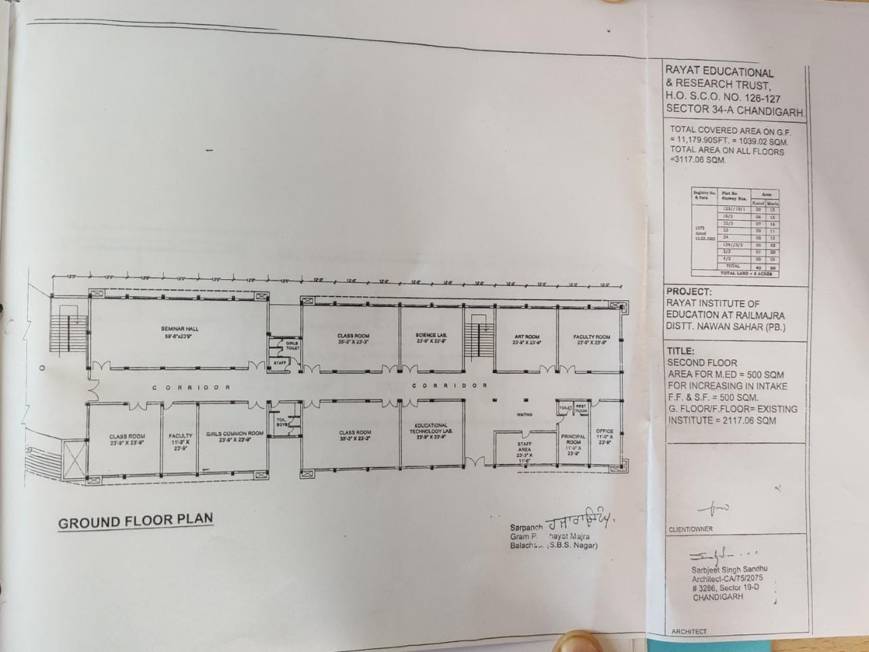

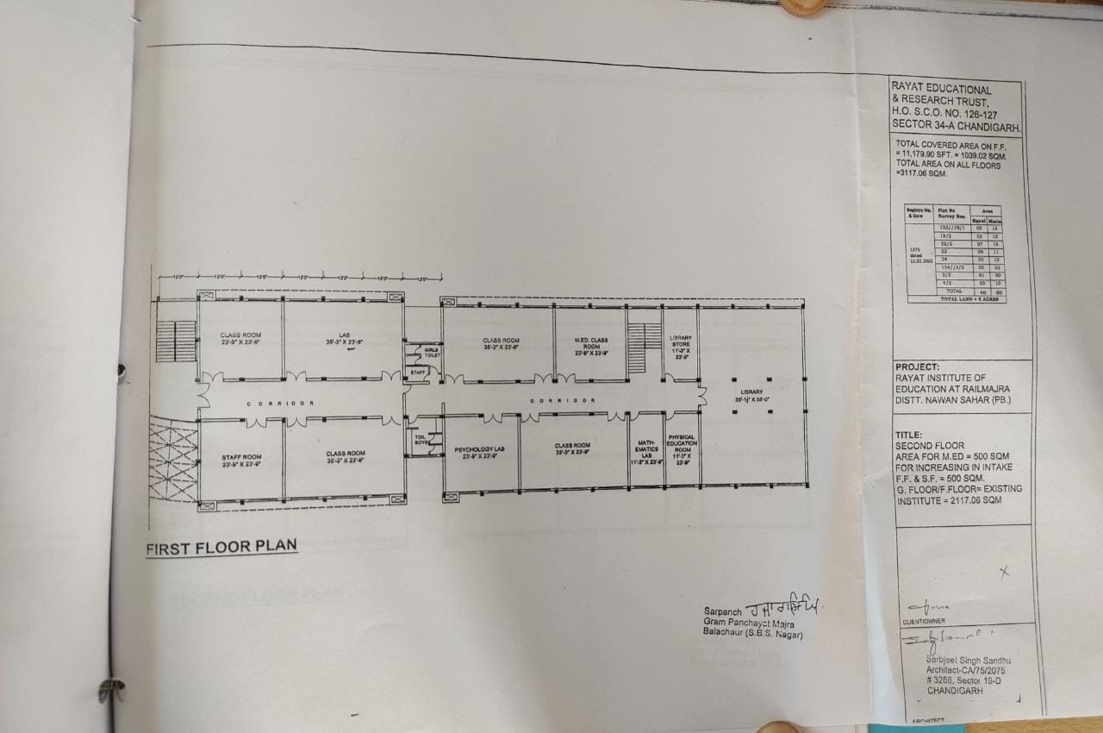
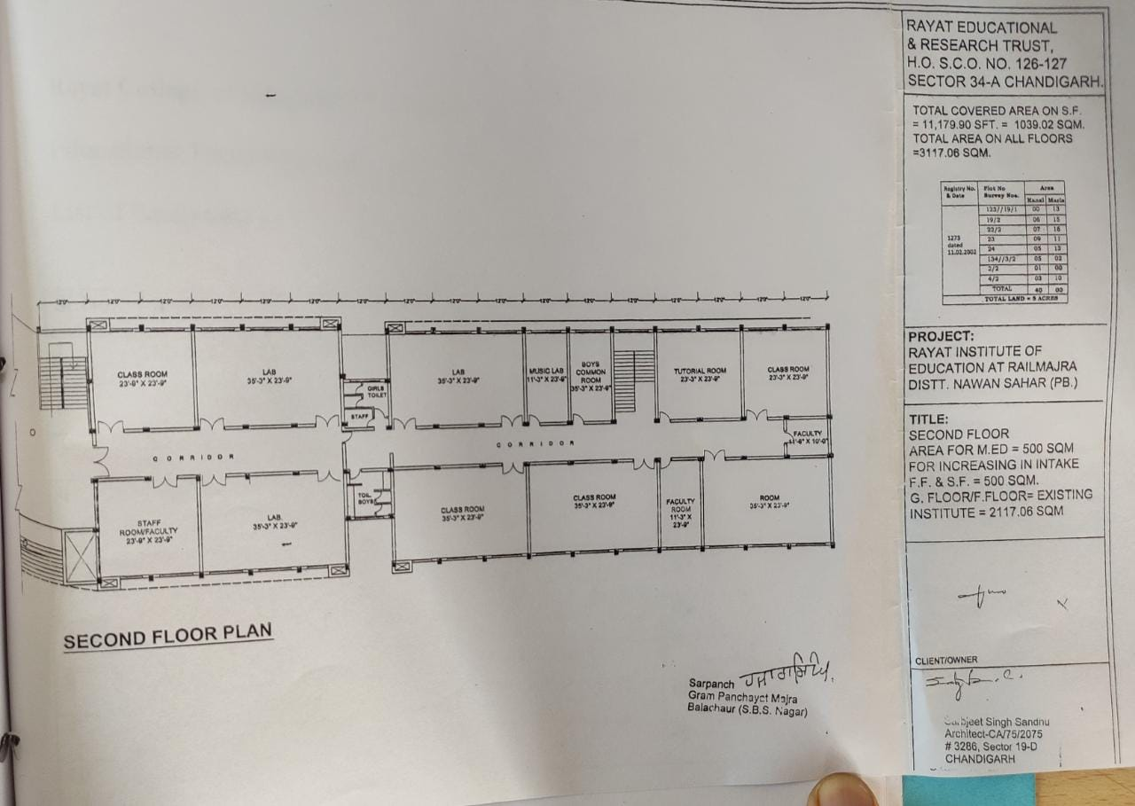
- Due to the pandemic situation, the institution started online classes and virtual meeting for students by imparting them knowledge regarding their curriculum.
- Details of names of books in the library, referred journals subscribed to and additions
(For Session 2020-2021)

S. No. | Resources | Quantity
1. | Total Books | 10129
2. | Book Bank | 865
3. | Total Journals  National  International | 07  06  01
3. | Total Magazines | 09
4. | Total Newspapers | 05
5. | DELNET (Education E-Journal) | 30
6. | Encyclopedias | 45
7. | DELLSOFT Software | 01

List of Newspapers

(2020-2021)

S.No | Name of Newspapers | Periodicity
1 | The Tribune | Daily
2 | The Times of India | Daily
3 | The Ajit | Daily
4 | The Hindustan Times | Daily
5 | Dainik Bhaskar | Daily

List of Magazines
(2020-2021)
S.No. | Name of the Magazines | Periodicity
1. | Outlook | Weekly
2. | Employment News | Weekly
3. | India Today | Weekly
4. | Pratiyogita Darpan | Monthly
5. | Gyanam | Monthly
6. | GrehShobha | Bimonthly
7. | G K Today | Monthly
8. | CSR | Monthly
9. | Tits Bits | Monthly

List of Journals
(2020-2021)
S.No. | Name of the Journal | Periodicity
01. | EduTracks | Monthly
02. | Journal of Community Guidance and Research | Quarterly
03. | Gyanodaya: The Journal of Progressive Education | Bi-annual
04. | Asian Man (The) - An  International Journal | Bi-annual
05. | Educational Quest- An  International Journal Of Education And  Applied Social Sciences | Tri-annual
06. | Iassi- Quarterly Indian Association of Social Science Institute | Quarterly
07. | Journal of School Education Technology | Quarterly

- N/A
- N/A

